Vol:2, Pg:61-90, Yr: 2021-AJABTR

**64Cu-Bevacizumab as a better PET imaging agent in detecting breast cancer in MDA-MB-231 orthotopic and bone metastasis mice model compared to 18FDG**

Keya De Mukhopadhyay1, *, Ting-Tung Chang2 *, William Phillips2, Lu-Zhe Sun1, Beth Goins2

1Department of Cellular and Structural Biology, UT Health San Antonio, Texas, USA

2Department of Radiology, UT Health San Antonio, Texas, USA

* Equal contributors

Corresponding author: mukhopadhyaykeya@gmail.com

**Abstract**

Developing new imaging agents help in the detection of breast cancer with better sensitivity and specificity and it improves the patient outcomes significantly. This provides the physicians with improved early detection of breast cancer during the routine screening process and has the potential to help the surgeons in identifying the tumor margins more accurately for surgical resection. In this study, we evaluate the efficiency of 64Cu-bevacizumab to successfully detect the small tumors (5mm), large tumors (15mm) and metastatic sites in MDA-MB-231 breast cancer mouse models compared to 18FDG and conclude that 64Cu-bevacizumab is a promising PET (positron emission tomography) imaging agent with high possibility to be applied to human breast cancer detection, and could significantly improve patient survival.

**Keywords:** Breast cancer, Imaging agent, Biomarkers, PET

**1. Introduction**

Breast cancer is the most common malignant disease in western women [1, 2]. In US, breast cancer incidence in women is 1 in 8 (about 13 %) (www.breastcancer.org), and is the second leading cause of cancer death in women [1, 3]. In these patients, the primary tumor is not the main cause of the death but rather is due to metastases at distant sites. For new cases of breast cancer, 73 % were invasive and only 27 % were non-invasive (in situ) in 2019. Lung, liver, brain, pleura, and bone are the most common sites of breast cancer metastasis [4, 5]. Greater than 80% of patients with advanced disease have bone metastasis [2, 4]. Effective diagnostic tools are clearly needed in order to offer medical professionals useful information to control the disease. Several molecules, such as epidermal growth factor receptor 2 (ERBB2, also known as HER2/neu) [6], urokinase-type plasminogen activator (uPA) [7], and the matrix metalloproteinases (MMP1, MMP9) [8], have been discovered as a biomarkers for evaluating disease prognosis this disease. However, only imaging technology can provide an overall idea about the tumor size and metastasis distribution. Of all the imaging techniques, 18FDG PET imaging is one of the most powerful molecular imaging techniques currently available for clinical use for detection, staging, monitoring, and evaluating the prognosis of breast cancer [9]. 18FDG PET can offer whole body soft tissue and bone metastasis information simultaneously [10]. Nevertheless, 18FDG PET produces more false-negative findings for skeletal metastases than for non-osseous metastases because of the low uptake of 18FDG by bone tissue and also more false-positive findings because of the higher uptake of 18FDG by muscle, inflamed tissue, brain, heart and urinary system [11]. This study tested a new strategy in tumor detection based on angiogenesis rather other than glucose uptake in detecting in situ and metastatic breast cancer tumor.

1. Angiogenesis

Angiogenesis, the growth and formation of new blood vessels from pre-existing, nascent vasculature, is a fundamental process involved in several physiologic and pathologic situations, including the growth of tumor and metastasis [12]. In breast cancer, extensive research data implied that angiogenesis plays a very important role in its development, invasion, and metastasis [13].

1. VEGF

The increased synthesis of vascular endothelial growth factor (VEGF) is one of the most important features of tumor angiogenesis in various tumor tissues. VEGF is recognized as an essential regulator of normal and abnormal blood vessel growth [14]. Usually, the main source of VEGF is tumor cells, but tumor-associated stroma is also an important site of VEGF production, possibly in a tumor-dependent fashion [15-17]. Research showed most breast cancer cells have higher VEGF expression than normal tissues [18, 19]. Also, in breast cancer development, VEGF had been confirmed by numerous studies of its role in tumor growth, invasion, migration, metastasis [20], osteolytic bone metastasis [21] and osteoblastic bone metastasis [22], almost every important step of disease progression.

1. Bevacizumab

Bevacizumab (commercially named Avastin by Genentech, CA) is a humanized monoclonal antibody against VEGF. It binds to and neutralizes all human VEGF-A isoforms and bioactive proteolytic fragment. However, it cannot neutralize other members of VEGF gene family such as VEGF-B, VEGF-C, or VEGF-D [21]. Bevacizumab was approved by the U.S. Food and Drug Administration in 2004 for use in combination with standard chemotherapy in the treatment of metastatic colon cancer and most forms of metastatic non-small cell lung cancer [24]. It was approved for treatment of breast cancer in February 2008 [25]. Other oncological applications such as adjuvant / non-metastatic colon cancer, metastatic breast cancer, metastatic renal cell carcinoma, metastatic glioblastoma multiforme, metastatic ovarian cancer, metastatic hormone-refractory prostate cancer, and metastatic or unresectable locally advanced pancreatic cancer, were in clinical trials [26]. The terminal half-life of bevacizumab is 17-21 days [27].

* 1. 64Cu

64Cu has a half-life of 12.7 hours (β+: 0.655 MeV; 19%; β-: 0.573 MeV; 40%). This nuclide can be readily prepared by the cyclotron irradiation of enriched nickel-64 with 14 MeV protons [28]. It is particularly useful for small animal imaging because of the low energy of the positron emitted from the copper nucleus [29]. The positron energy of copper-64 is similar to that of fluorine-18, which gives high-resolution image. It is widely recognized as an ideal radionuclide for PET imaging of antibody trafficking [30] because the radioactive half life of 64Cu-mAb is much longer than that of 18FDG (110 min) and so the 64Cu-labele antibody can be used for monitoring the distribution and trafficking of antibody for a relatively longer period of time *in vivo*. FDA has approved 64Cu as a PET imaging tracer in some clinical trials [31, 32].

This study is intended to test the capability of in situ and metastasis tumor detection of 64Cu-bevacizumab in breast cancer orthotopic and bone metastasis model. Although we have verified the prior tumor detection capability than 18FDG of this probe in several different cancer xenograft and orthotopic models from our previous work, a successful PET imaging probe to tumor detection has to be able to detect metastasis as well.

In this study, we compared the tumor detection capability between two PET imaging probe, 64Cu-DOTA-bevacizumab and 18FDG, in breast cancer orthotopic and bone metastasis models established from MDA-MB-231 cell lines. The MDA-MB-231 cell line expresses enhanced green fluorescent protein (EGFP). Therefore, we are able to confirm the tumor burden by comparing the PET images with optical EGFP images. Biodistribution and image analysis were performed to quantify the result. Immunohistochemistry (IHC) study is used to understand the distribution of tumor VEGF (human), host VEGF (mouse), and bevacizumab in tumor and hematoxylin and eosin stain (H&E stain) was also performed to locate cancer cells in the bone.

1. **Materials and Methods**
2. Radiolabeling and Quality Control

From our previous work, the reliability of the radiolabeling chemistry and the stability of the 64Cu-DOTA-bevacizumab had been verified. The detailed procedure we used for bevacizumab (Avastin, Genetech, South San Francisco, CA) radiolabeled with positron emitter 64Cu (64CuCl2 in 0.1 M HCl; radionuclide purity >99%, University of Wisconsin) were described in our previous work where Wipke and Wang’s method was applied [33]. Basically, antibodies mentioned above were conjugated with DOTA-NHS-ester (Macrocyclics, Dallas, TX) first and then radiolabeled with 64Cu.

*Conjugation.* First, antibody solutions were buffer exchanged with PBS using YM-30 Centricon® centrifugal filters (Millipore, Billerica, MA). For conjugation, antibodies were reacted with DOTA-NHS-ester in 0.1 M Na2HPO4 buffer of pH 7.5 at 4°C for 12 - 16 h in a molar ratio of DOTA-NHS-ester: antibody = 100: 1. After conjugation, the reaction mixture was centrifuged repeatedly (5 times) through a YM-30 Centricon® centrifugal filters again with 0.1M pH 6.5 ammonium citrate buffer in order to remove unconjugated small molecules. The concentrations of purified antibody-conjugate were determined by measuring the absorbance at 280 nm of a UV spectrophotometer (Eppendorf, Westbury, NY).

*Labeling.* When labeling with 64Cu, 1 mg DOTA-conjugated antibody and 5 mCi (185 MBq) of 64Cu were incubated in pH 6.5, 0.1 M ammonium citrate at 43°C for 45 minutes to 1 hour. Labeled mAbs were separated by a size-exclusion column (Bio-Spin6, BIO-RAD Laboratories).

1. Development of Tumor Model

*Cell Culture*

Highly metastatic EGFP-expressing MDA-MB-231 cells [19] were cultured and maintained in DMEM with 10% fetal bovine serum at 37°C in an incubator with 5% CO2.

*Orthotopic Model*

Female athymic nude mice (Harlan Sprague Dawley Inc., Indianapolis, IN) at 4-5 weeks age were used for EGFP-expressing orthotopic model (n = 5). Each mouse was inoculated with 106 EGFP-expressing MDA-MB-231 cells in 100 µL phosphate buffered saline (PBS) into the inguinal mammary fat pad by using a 27-gauge needle attached to a 1-mL syringe. The tumor production rate in our lab using this method is nearly 100%.

*Bone Metastasis Model*

An intracardiac injection model for experimental bone metastasis was used in this study, as previously described [34, 35]. Female athymic nude mice (Harlan Sprague Dawley Inc., Indianapolis, IN) at 4-5 weeks age were used for this model (n = 5). Briefly, the EGFP-expressing MDA-MB-231 cells were harvested from subconfluent cultures. After harvesting, 105 cells in 100 µL PBS were injected into the left cardiac ventricle of anesthetized mice with 27-gauge needle attached to a 1-mL syringe using a micromanipulator. The successful injections were indicated by the pumping of red blood into the syringe. Ketamine (33ug/gram of mice) and Xylazine (4ug/gram of mice) cocktail were used as the mice anesthetic during tumor inoculation.

The animals were fed and housed following the protocol for the nude mice living environment at the animal facility at UT Health San Antonio, and were checked every other day after the tumor cell inoculation.

1. Imaging Method
2. *Overall details of micro PET and micro CT acquisition*

All the mice were anesthetized with 2-3 % isoflurane in 100% oxygen during injection and scanning. Gamma Medica-Ideas FLEX preclinical system (Gamma Medica-Ideas Inc, Northridge, CA) was used for micro PET/CT acquisition. With the whole mouse within the field of view, micro CT image were acquired before each PET scan using fly mode to acquire quality image and decrease radiation dose to the mice (75 kV, 185 μA). All the PET image sets acquired (64Cu and 18FDG) were normalized to the highest pixel value of itself in order to parallel compare the tumor detection of these two probes. The images were reconstructed by using the software offered from Gamma Medica-Ideas Inc and were fused by Amira based software VIVID (Gamma Medica-Ideas Inc, Northridge, CA). The formula we used for normalization of each image set is shown below.



1. *Comparison between 64Cu-bevacizumab and 18FDG in tumor detection in orthotopic model*

Female athymic nude mice (n = 5) bearing EGFP-expressing MDA-MB-231 tumors were used for comparing the capability of in situ tumor detection between 64Cu-bevacizumab and 18FDG. 64Cu-bevacizumab and 18FDG were injected into the same mouse in order to parallel compare their effect. Tumor bearing mice in orthotopic group were scanned twice for different study purposes. First scan were performed when the longest axis of tumors achieved to 3-4 mm (approximately 10 days after implantation) for early tumor detection study. Later, when the longest axis of tumors grew up to ~15mm, another scan was performed to test the capability in detecting tumor at a larger size.

18FDGand 64Cu-bevacizumab were injected intravenously via a lateral tail vein into tumor bearing mice. 18FDG was injected into the same mouse 24 hours before the 64Cu-bevacizumab administration. This design not only offers enough time (>10 half-lives) for 18FDG to decay to background prior to 64Cu-bevacizumab image acquisition, but also will not cause significant change in size for MDA-MB-231 tumors. Therefore, we can parallelly compare the tumor detection ability of these two agents in the same mouse. While scanning, all mice were supine on the bed of the scanner.

*18FDG PET imaging.*

Mice were fasted overnight before the scan was performed to increase contrast. Animals were kept warm by using heating pad and a thermal lamp for at least one hour before 18FDG injection and last until the scan was performed. This was to reduce the uptake in the brown fat and muscle. 18FDG images were acquired in static PET imaging mode for 10 minutes at the time point of 1 h p.i. The administrating dose of 18FDG is 200µCi in a 200 µl volume.

*64Cu-bevacizumab PET imaging.*

64Cu-bevacizumab was injected at the dose of 200µCi/40µg mAb in 200 µl saline. No special care such as fasting and heating was required. Mice from each group were scanned at 1, 4, 24, and 48 h p.i. in static PET imaging mode for 10, 10, 15, and 20 minutes, respectively.

*Optical imaging*

Tumor growths in orthotopic models were also monitored by green florescent imaging using a Nikon SMZ1500 (Nikon, Tokyo, Japan) fluorescence stereoscope attached to a CoolSNAP CCD camera (Photometrics, Tucson, AZ) in order to confirm and compare the tumor location and metastatic sites findings on micro PET images.

1. *Comparison between 64Cu-bevacizumab and 18FDG in tumor detection in bone metastasis model*

The experiment method was same as the details mentioned for orthotopic model except the mice were prone on the bed of the scanner.

1. Biodistribution Study

Animals were sacrificed right after the 44-hour post-injection images were acquired. Blood was collected, and tumors and 13 other unaffected organs and tissues were harvested and weighed. After blood sample had been collected from the heart (~500-1000μl), 10 ml of saline was injected into left ventricle when heart was still beating to flush out the residual blood in the tumor and organs. For metastatic model, all tumors found after dissecting of each mouse were collected into the same vial for measurement. Radioactivity in each tissue (cpm) was measured by using the γ-scintillation counter (Wallac-PerkinElmer, Waltham, MA). Percentages of the injected dose/gram (%ID/g) were calculated for each tissue/ organ by the following formula.



1. Image Analysis

For orthotopic model, tumor-tissue contrasts in PET images were estimated to distinguish the difference between 18FDG and 64Cu-DOTA-bevacizumab. The whole tumor was chosen by drawing regions-of-interest (ROI) along the edge of the tumors in all slices that tumor appeared. Three tissues other than tumor were also chosen as tissue-of-interest for estimating 3 tumor/ tissue contrasts. Tissues of interest are abdomen, muscle, and the organ close to the orthotopic region (lung) to each mouse. Average pixel values of each tumor were also acquired by drawing regions-of-interest (ROI) along the edge of the tumors. In the same slice, average pixel values of three tissue-of-interest were obtained by drawing ROIs in correspondent position. ROIs of muscles were acquired on the contralateral thigh of tumor. The images were analyzed by using VIVIDTM and the formula we used to calculate the contrast is listed below.



Student’s t-test was conducted to the results between different groups. *P*<0.05 is considered statistically significant.

1. Immunochemistry

After 44 h p.i., the tumor harvested from mice injected with 64Cu-bevacizumab was fixed in 10% formalin, paraffin-embedded, sectioned, and sent to pathology department for IHC in order to verify the distribution of hVEGF, mVEGF, and the localization of bevacizumab. Antibody we used to locate hVEGF was bevacizumab itself and anti-mVEGF antibody was from R&D systems. (Cat. #: AF-493-NA, Minneapolis, MN) was applied. Anti-human IgG (Cat. #: ab6759, Abcam, Cambridge, MA) were used to locate the tracer, 64Cu-bevacizumab. For metastasis model, the bone metastatic lesions confirmed by green florescent imaging and 64Cu-bevacizumab PET imaging were collected. The bone lesions were fixed in 10 % formalin for 24 h, then decalcified in 10 % EDTA, paraffin-embedded, and sent to pathology for IHC and H&E stain to verify the distribution of cancer cells, human VEGF, mouse VEGF and bevacizumab by using the antibodies mentioned above.

1. **Results**
2. Radiolabeling and Quality Control

The radiolabeling of bevacizumab was successfully carried out in our lab by conjugation method we developed, followed by addition of 64Cu [34]. The 64Cu-labeling yield was ~85%. This method gave a radiochemical purity of >92% (FPLC). The serum challenge studies demonstrated that 85% of radiolabeled antibody was still intact, even at 24 hours.

1. 64Cu-bevacizumab PET Imaging in Tumor Detection Compared to 18FDG

According to the imaging results, 64Cu-bevacizumab showed promising capability of tumor detection than 18FDG start from 20h p.i. and achieving very satisfying result at 44h p.i. In orthotopic model, 64Cu-bevacizumab successfully detected all tumors of both small size (~5mm) (Figure 1 (A)) and large size (~15mm) (Figure 1 (B)).

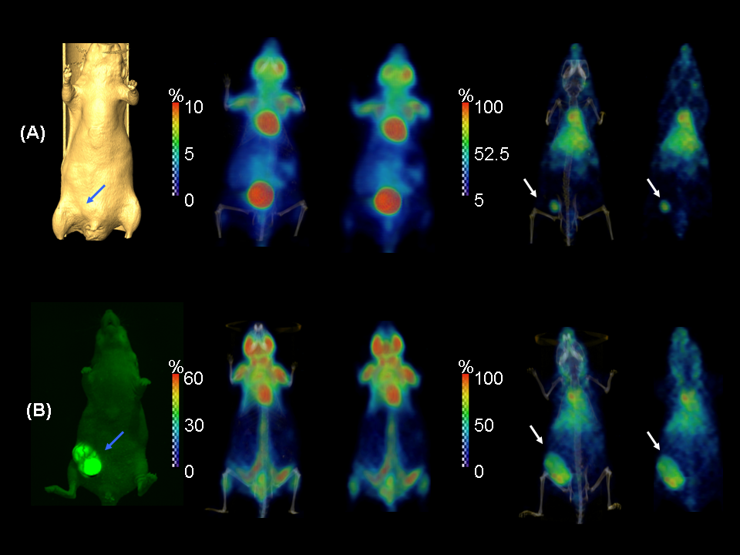

**Figure 1. Comparisons of images in tumor detection between 18FDG and 64Cu-bevacizumab in the same mouse of MDA-MB-231 orthotopic model.**

The study groups shown here are **(A)** orthotopic models with small tumor. The long axis of tumor is ~5 mm. This is the group to test early tumor detection. **(B)** Orthotopic model with large tumor. The long axis of the tumor is ~18 mm. All the PET images were normalized to the highest pixel value in its data set. The percentage value of a specific organ could be determined by comparing the color of the tissue with the corresponding color bar. The images of each column from the left to the right are, first, the isosurface rendered microCT images (A)/ optical EGFP image (B) to illustrate the position of the tumors; second, the 18FDG microPET/CT fused images; third, 18FDG microPET images only; fourth, 64Cu-bevacizumab microPET/CT fused images; and fifth, 64Cu-bevacizumab microPET images only, respectively. All the 18FDG images were acquired at 1h p.i. when all the 64Cu-bevacizumab images were acquired at 44h p.i. If the tumor showed in the image, it is marked by the arrows.

However, 18FDG imaging failed in detecting small tumors and also failed or offered ambiguous signal in large tumor detection. Based on the normalized images, for 64Cu-bevacizumab, the average pixel value at the tumor site was >75% of the highest pixel value for both small and large size of tumors. For 18FDG imaging, the pixel value is nearly background for small tumors and <30% for large tumors. These quantified data verified the visual difference we noticed from the image. 64Cu-bevacizumab imaging also offered fewer non-tumor related findings (cleaner background) than 18FDG. Liver was the other organ with high accumulation. The conventional high 18FDG accumulated organs or tissues such as brain, heart, muscle, kidneys, bladder were not shown in the 64Cu-bevacizumab imaging. 64Cu-bevacizumab showed clear contour of tumors in the images.

In metastasis model, 64Cu-bevacizumab showed similar promising results as in orthotopic model by confirming the tumors from optical imaging and by H&E staining results. We successfully located the bone metastatic sites at jaws, scapulas, shoulders, knees, and solid tumor behind the neck (Figure 2, 3, 4, and 5).

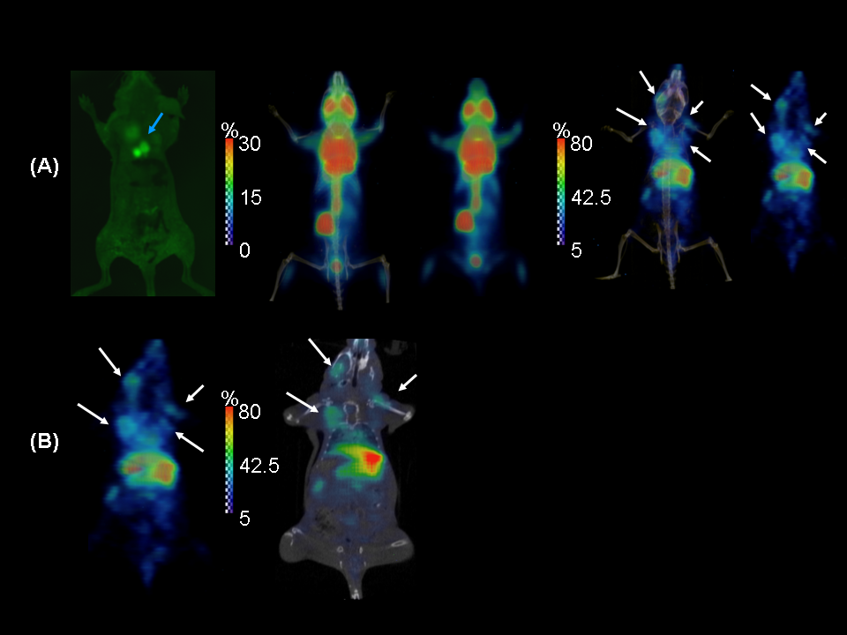

**Figure 2. Comparisons of images in tumor detection between 18FDG and 64Cu-bevacizumab in the same mouse of MDA-MB-231 bone metastasis model (Mouse BM-1).**

The images shown in this figure were all from one mouse of bone metastasis group (Mouse BM-1). **(A)** The images of each column from the left to the right are, first, optical EGFP image to illustrate the position of the tumors; second, the 18FDG microPET/CT fused images; third, 18FDG microPET images only; fourth, 64Cu-bevacizumab microPET/CT fused images; and fifth, 64Cu-bevacizumab microPET images only, respectively. Bone metastatic lesions at left jaw, left and right scapula, and right should (humerus) can been diagnosed on 64Cu-bevacizumab PET images but not on 18FDG. 64Cu-bevacizumab PET images also revealed more metastatic sites than the optical image at the very right. **(B)** Left, the 64Cu-bevacizumab PET image compared with PET/CT fused tomographic image (right). The fused tomographic image clearly showed the location of the lesions. All the PET images were normalized to the highest pixel value in its data set. The percentage value of a specific organ could be determined by comparing the color of the tissue with the corresponding color bar. All the 18FDG images were acquired at 1h p.i. when all the 64Cu-bevacizumab images were acquired at 44h p.i. If the tumor showed in the image, it is marked by the arrows.

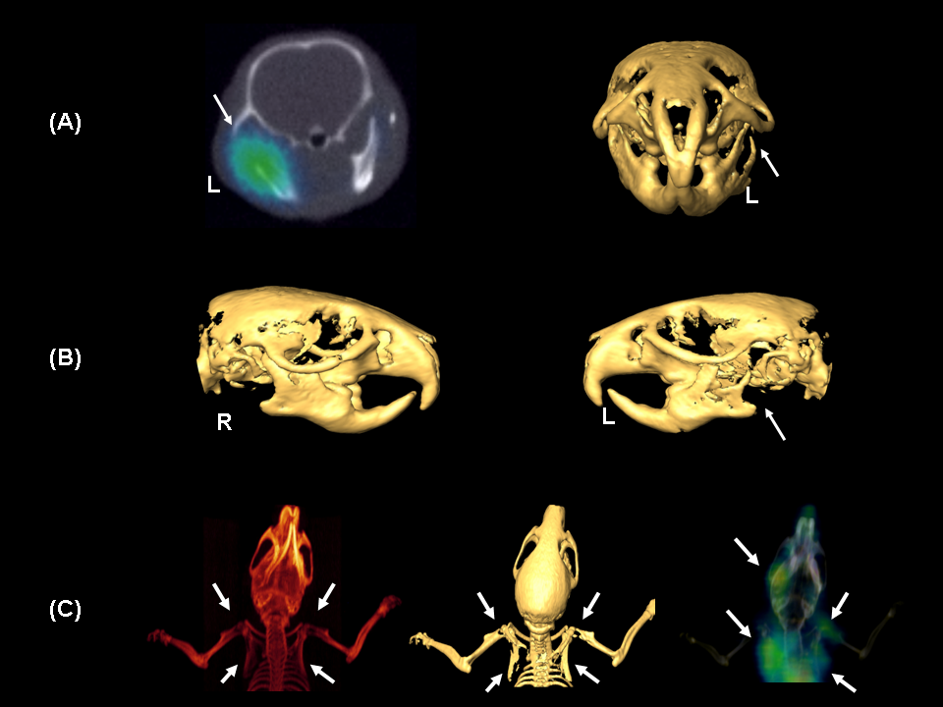

**Figure 3. Details of 64Cu-bevacizmab in bone metastasis model (Mouse BM-1).**

**(A)** Left, micro CT/PET fused 64Cu-bevacizumab tomographic image which clearly revealed the lesion at left mandible. Right, micro CT isosurface rendered image of the skull viewed from the front. It showed osteolytic bone metastasis in left mandible (the eroded area) by comparing with right side. **(B)** The micro CT isosurface rendered image of the skull from the view of both sides. Clear bone erosion can be seen at the left mandible by comparing with right side. (C) Projective (left) and isosurface rendered (middle) micro CT imaging showed clear osteolytic metastasis at both shoulders and scapulas. 64Cu-bevacizumab microCT/PET image revealed the lesions at correspondent locations (right). All the images in this figure were from the same mouse, Mouse BM-1. All 64Cu-bevacizumab images were acquired at 44h p.i. If the tumor showed in the image, it is marked by the arrows.

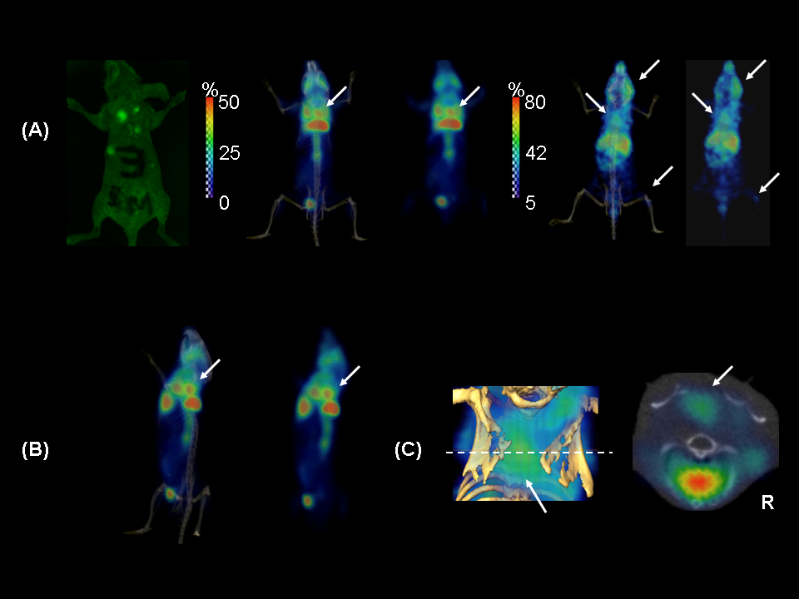

**Figure 4. Comparisons of images in tumor detection between 18FDG and 64Cu-bevacizumab in the same mouse of MDA-MB-231 bone metastasis model (Mouse BM-2).**

The images shown in this figure were all from another mouse of bone metastasis group (Mouse BM-2). **(A)** The images of each column from the left to the right are, first, optical EGFP image to illustrate the position of the tumors; second, the 18FDG microPET/CT fused images; third, 18FDG microPET images only; fourth, 64Cu-bevacizumab microPET/CT fused images; and fifth, 64Cu-bevacizumab microPET images only, respectively. Bone metastatic lesions at right jaw, right knee, and a non-osseous lesion at posterior neck can been diagnosed on 64Cu-bevacizumab PET images. 18FDG clearly detected the non-osseous lesion at posterior neck as well, but not those osseous lesions. 64Cu-bevacizumab PET images also revealed more metastatic sites than the optical image at the very right. **(B)** Lateral view of 18FDG image to clearly see the non-osseous lesion at posterior neck (arrow). The other high 18FDG uptake findings around it are brown fat and heart. CT/PET fused image is shown at left; right one is PET image only. (C) Left, CT/PET 64Cu-bevacizmab image of the non-osseous lesion at posterior neck. The dashed line is location the tomographic image was taken. Right, CT/PET fused 64Cu-bevacizumab tomographic image which clearly revealed the lesion at posterior neck. All the PET images were normalized to the highest pixel value in its data set. The percentage value of a specific organ could be determined by comparing the color of the tissue with the corresponding color bar. All the 18FDG images were acquired at 1h p.i. when all the 64Cu-bevacizumab images were acquired at 44h p.i. If the tumor showed in the image, it is marked by the arrows.

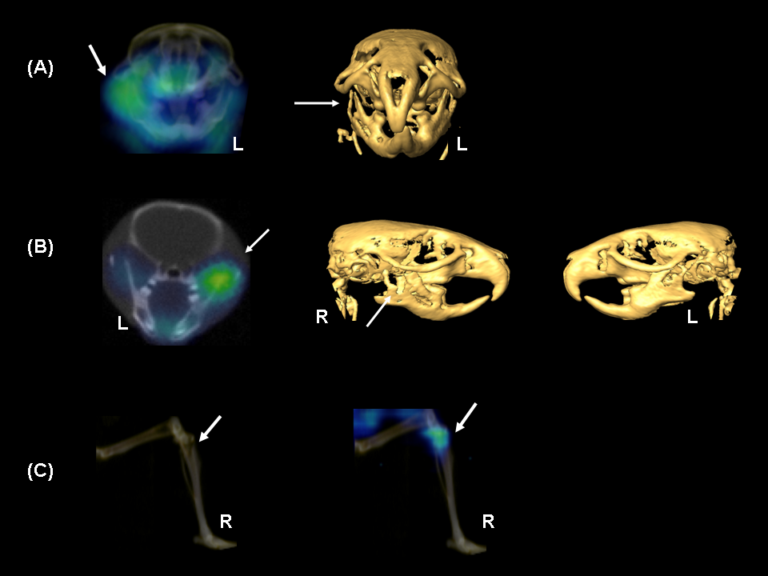

**Figure 5. Details of 64Cu-bevacizmab in bone metastasis model (Mouse BM-2).**

**(A)** Left, micro CT/PET fused 64Cu-bevacizumab image which clearly revealed the lesion at right mandible. Right, micro CT isosurface rendered image of the skull viewed from the front. It showed a distinct osteolytic bone metastasis in right mandible (the eroded area) by comparing with left side. **(B)** micro-CT/PET fused 64Cu-bevacizumab tomographic image which clearly revealed the location of the lesion at right mandible. The micro CT isosurface rendered image of the skull from the view of both sides. Clear bone erosion can be seen at the right mandible by comparing with left side. (C) Left, a osteolytic area can be seen on the projective micro CT imaging of right lower limb. Right, 64Cu-bevacizumab microCT/PET image revealed the lesions at correspondent locations (right). All the images in this figure were from the same mouse, Mouse BM-1. All 64Cu-bevacizumab images were acquired at 44h p.i. If the tumor showed in the image, it is marked by the arrows.

Some findings showed on 64Cu-bevacizumab PET images could not even be detected on optical images but H&E stain confirmed the existence of cancer cells. This showed the great sensitivity of this probe in metastasis detection. 18FDG failed in detecting most of the lesions, but successfully detected one soft tissue tumor behind the neck. (Figure 4, (B)). In bone metastasis group, the background signals are noisier than

other xenograft and orthotopic models we have investigated. This may be because there are multiple micro-metastatic sites are developing.

1. Biodistribution of 64Cu-bevacizumab

The biodistribution results of orthotopic and bone metastasis model is shown in Figure 6.

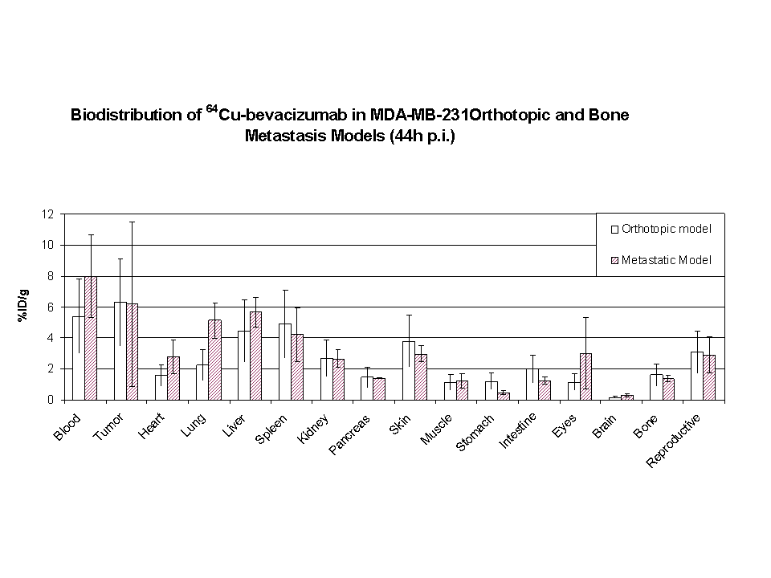

**Figure 6. Biodistribution results.**

The biodistribution of 64Cu-bevacizumab in MDA-MB-231 orthotopic and bone metastasis models at 44h post injection. Data presented in format of %ID/g ± SD.

Tumors have the highest %ID/g within all the tissue we collected. The reproductive system (uterus and ovary) are high accumulation organs in the mice. This may be because VEGF is highly expressed in these organs. Other organs with high uptake are liver and spleen. Tumor uptake is ~6 times higher than muscle. In metastatic model, tumors are the tissue with the highest uptake besides blood and all the other organs has similar uptake as orthotopic group.

1. Tumor-tissue Contrast of 64Cu-bevacizumab and 18FDG

The contrast of tumor-muscle, tumor-Abdoman, and tumor-Lung obtained by analyzing 64Cu-bevacizumab image in orthotopic model is 8.29 ± 3.56, 3.81 ± 0.99, and 1.79 ± 0.59, respectively. Same contrast offered by 18FDG image is -0.3±0.21, 0.25 ± 0.35, and0.34 ±0.33, respectively.

1. Immunochemistry

The histology study verified the presence of VEGF in both MDA-MB-231 orthotopic and metastatic tumors.

1. **Discussion**

Breast cancer is one of the most frequent cancers and one of the primary causes of death due to malignancy in western women [1]. Within all diagnostic methods, imaging technology is still the most powerful and most efficient way to locate both primary and metastatic tumors and stage the disease. This project is not only to verify 64Cu-bevacizumab can offer better detection in locating primary, soft tissue metastasis, and bone metastasis in breast cancer than 18FDG, but also prove the concept of that targeting VEGF is a reasonable strategy in detecting metastasis in other type of cancers since VEGF played a significant role in tumor metastasis to most of cancer types.

Imaging modalities, which are commonly used to detect breast cancer are ultrasound (US), mammography, plain radiology (XR), computed tomography (CT), magnetic resonance imaging (MRI), skeletal scintigraphy (SS), single photon emission computed tomography (SPECT), and positron emission tomography (PET). Each modality has its own pros and cons because of its intrinsic limit. Briefly, US and mammography can only be used to detect soft tissue tumors in limited area. XR is mainly used for detecting osteolytic lesions resulting from bone metastasis. However, bone metastasis can only be detected when at least 30-75% normal mineral content is lost [10], and this means the metastatic lesion may not appear on XR for at least several months. CT is generally considered to be highly sensitive in tumor detection. Metastasis in soft tissue such as brain, lung, liver, and lymph nodes can usually be accurately detected. CT can detect metastases in the bone marrow before bone destruction becomes evident [37]. Yet, high radiation dose, relatively high cost, and the ability to scan only limited anatomic areas at a time are primary disadvantages of this technology [10]. Hence, CT is not yet suitable for whole-body screening purposes. MRI offers higher contrast resolution than CT for visualizing tumors in soft tissue, bone marrow, and vertebral and spinal cord compression [10]. However, MRI cannot be used for detecting the destruction of bone structure because cortical bone does not produce signals for MRI. High cost and limited scan region also make MRI an unlikely whole-body screening tool. SS is the most common means to detect bone metastasis [38], but it is more sensitive for osteoblastic lesions than for osteolytic lesions which accounts for about 85% of breast cancer bone metastasis [39, 40]. SPECT uses the same radionuclide markers as does SS [41]. Although SPECT is more sensitive and offers better contrast resolution than SS, it still is not good in detecting osteolytic lesions. 18FDG PET imaging can be used for whole-body scanning to detect metastases in both soft tissue and bone. It offers satisfying sensitivity in detecting occult primary breast lesions, and metastasis in axillary lymph node and other organs. Because of low uptake of 18FDG by bone, 18FDG PET imaging produces more false-negative findings for skeletal metastases than for nonosseous metastases [10]. Studies also suggest that 18FDG PET imaging is more sensitive in detecting osteolytic than osteoblastic metastasis [10]. On the other hand, organs or tissues with higher uptake of 18FDG such as muscle, inflammation tissue, brain, heart, and urinary system, will result in false-positive findings [39]. Nevertheless, 18FDG PET imaging is still the most effective whole-body screening tool for detecting and staging breast cancer.

Solid evidence shows angiogenesis and VEGF play an important role in both local tumor growth and distant metastasis in breast cancer, including bone and soft tissues [13]. This appears to be the case in many forms of breast cancer, including invasive/noninvasive, lymph node - / lymph node +, inflammatory breast cancer, and metastatic breast cancer [42-46]. Higher expression of VEGF in breast cancer cells than in surrounding normal tissues has been verified [48]. Within all the pro-angiogenic factors, VEGF appears to be the only factor expressed throughout the entire life cycle of a breast tumor [49]. Weigand and colleagues demonstrated that VEGFR-2 is functional on the surface of breast cancer cells which can be stimulated by VEGF [50]. This finding indicated the presence of an autocrine signaling loop distinct from the angiogenesis and it may be related to tumor cell growth or prevents tumor cells from starting apoptosis. Breast cancer metastatic process includes detachment, intravasation and extravasation from circulation, migration, attachment, and angiogenesis at distant site. VEGF has verified roles in each of these steps. MMPs family and uPA plays an important role in ECM degradation which is a significant step in the detachment and attachment of tumor cells. VEGF induces the expression of MMPs and uPA [51, 52]. VEGF can strongly increase the permeability of the blood vessel and this increased permeability helps the intravasation and extravasation of tumor cells from circulation [19]. In brain metastasis, VEGF modulates the migration of cancer cells through the blood-brain barrier (BBB) by regulating the brain microvascular endothelial cell permeability [19]. Osteoblasts are the cells which play a dominant role in osteoblastic bone metastasis. Research shows osteoblasts produce VEGF in order to start this progress [22, 53]. On the other hand, in osteolytic bone metastasis, the primary bone metastatic type in breast cancer, tumor cells release VEGF to interact with monocytes, the precursors of osteoclasts, to induce differentiation into osteoclasts [21]. These facts make VEGF an ideal target for primary and metastasis tumor detection and our imaging results prove it.

Confirmed by EGFP imaging, our results showed 64Cu-bevacizumab not only successfully detected all the tumors in orthotopic model, both in small and large size, but also most of metastasis sites in our metastasis model. One of the mice in orthotopic group was found to have metastasis in peritoneum from 64Cu-bevacizumab PET imaging, and this finding was verified by optical imaging and observed during dissection (Figure 7).

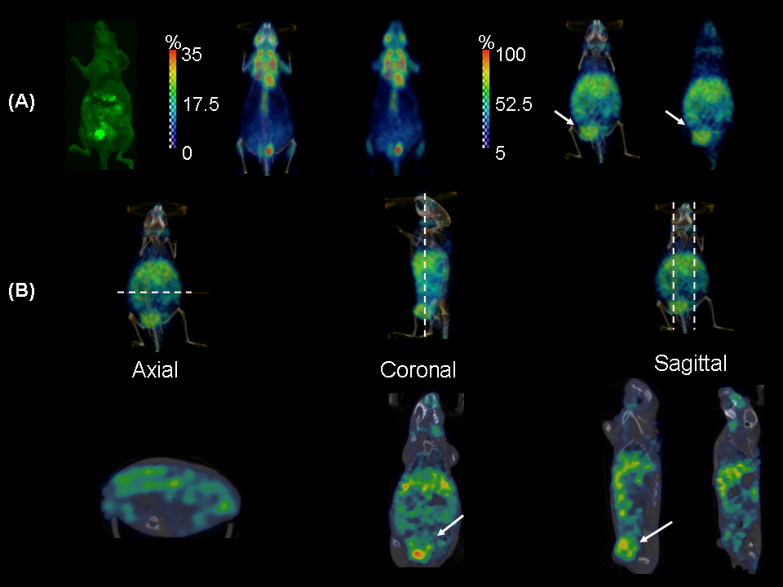

**Figure 7. 64Cu-bevacizmab image in MDA-MB-231 orthotopic model with peritoneum metastasis.**

**(A)** A mouse in orthotopic models with peritoneum metastasis. The metastatic lesions and the primary tumor can be clearly seen on optical image (right) and 64Cu-bevacizumab PET image. 18FDG showed blurry shadows in metastatic sites but no signals for primary tumor. The long axis of primary tumor is ~12mm. All the PET images were normalized to the highest pixel value in its data set. The percentage value of a specific organ could be determined by comparing the color of the tissue with the corresponding color bar. The images of each column from the left to the right are, first, the optical EGFP image to illustrate the position of the tumors; second, the 18FDG microPET/CT fused images; third, 18FDG microPET images only; fourth, 64Cu-bevacizumab microPET/CT fused images; and fifth, 64Cu-bevacizumab microPET images only, respectively. All the 18FDG images were acquired at 1h p.i. when all the 64Cu-bevacizumab images were acquired at 44h p.i. If the primary tumor showed in the image, it is marked by the arrows. **(B)** The PET/CT fused tomographic images from different view. The upper raw is the PET/CT fused whole body image to reveal the position the tomographic image were taken (white dashed line). The lower row is tomographic image of different plane. Arrows showed where the primary was. The bright spots spread out in the abdomen area are the peritoneum metastatic lesions.

This observation suggested 64Cu-bevacizumab may be useful for detecting peritoneal metastasis which is difficult to be detected by 18FDG. However, further studies are needed for this hypothesis. 18FDG imaging failed to detect most of the tumors in orthotopic and metastasis models, and these images had numerous strong non-tumor related lesions (false-positive). 64Cu-bevacizumab offered much fewer non-tumor related background than 18FDG. Typical “hot spots” in 64Cu-bevacizumab mouse image were heart, liver and spleen. According to the biodistribution data, blood is the tissue with highest %ID/g, followed by tumor, spleen, liver and reproductive system by order. We believe high %ID/g in blood is because bevacizumab has a relatively long half-life (19~21 days) compared to other antibodies. This could explain why the heart uptake is not that significant after we removed the blood when we perform biodistribution study since it is high accumulation site on image. High accumulation in liver was because the antibody metabolism and it may lead to a question if a tumor in the liver could be detected. Study using 111In-bevacizumab to imaging liver metastases of colorectal cancer patients showed acceptable contrast still achievable even when located in the liver [54]. Reproductive system had relatively high %ID/g is because VEGF is expressed in ovary and uterus, especially during menstrual cycle [13].

The contours of the primary tumors in 64Cu-bevacizumab image are clear. This characteristic could help physicians decide the size of tumor and may be able to help the radiation oncologist decide the CTV (clinical treatment volume) if this imaging probe could be applied clinically in the future.

There are only two physiological angiogenesis processes in adults, wound healing and female menstrual cycle. All others are pathologically related, such as cancer, vascular malformations, psoriasis (skin), diabetic retinopathy (eye), and arthritis (joint) [55]. Most of the diseases relative to excessive angiogenesis could be easily distinguished from solid tumor. However, this characteristic may cause difficulties in detecting metastases in female reproduction system. As well as in detecting bone metastases in arthritis sites. False-positive findings may appear under these conditions. 64Cu-bevacizumab should have advantage in detection compared with 18FDG in detecting metastatic brain tumor because of the lower uptake of 64Cu-bevacizumab compared to 18FDG in brain cells. Argument may be raised that if 64Cu-bevacizumab can penetrate BBB or not. However, for metastatic tumor in brain, the BBB at the tumor site should have been destroyed during the invasion of tumor cells. Therefore, bevacizumab should not be blocked by BBB. Yet, more studies are needed for these conditions. A previous study from our group also reveals that this probe can successfully detect the metastasis in brain [56].

Bevacizumab is a FDA approved drug and has been widely investigated. 64Cu is approved by FDA in some clinical trials for human imaging. Therefore, this new imaging agent has much higher possibility than other new probes to be applied to humans faster. PET offers many advantages over other imaging modalities especially in whole-body screening. The translation of promising new tracers to clinical applications can be facilitated because of the known safety issues of this probe and the popularity of clinical PET and PET/CT.

Several previous studies have shown the image intensity can be correlated to VEGF-A expression[57, 58].Tumor-to-tissue contrast values obtained by analyzing PET imaging are identical to the values assessed by γ-counting of excised samples. These results showed it is possible to use PET for quantification studies of this drug in the future to distinguish benign and malignant lesions, and correlated with prognosis. It is also possible to use this as an angiogenesis marker to evaluate the responses of therapy.

1. **Conclusion**

64Cu-bevacizumab successfully detected the small tumors (5mm), large tumors (15mm) and metastatic sites in MDA-MB-231 breast cancer mouse models whereas 18FDG failed to detect most these lesions. At 44h p.i., 64Cu-bevacizumab offered fewer non-tumor related false positive findings and sufficient contrast differences for detecting in situ and metastatic tumor compared with 18FDG. We demonstrated the promise of a pre-clinical tumor detection probe, which has high possibility to be applied to human breast cancer detection and other cancers as well.

**Acknowledgment:** Beth A. Goins, Ph.D., a biochemist and former professor in the Department of Radiology, UT Health San Antonio, who passed away in 2018 after a courageous battle with cancer, provided many insightful discussions for this study, shared research facilities for the imaging and helped in image analysis.

**References**

1. DeSantis CE, Jiemin M, Gaudet MM, Newman LA, Miller KD, Sauer, AG, Jemal A, Siegel RL. Breast Cancer Statistics 2019. CA: A Cancer Journal for Clinicians. 2019; 69 (6):1-14. doi:10.3322/caac.21583

2. Weigelt B, Peterse JL, van't Veer LJ. Breast cancer metastasis: markers and models. Nat Rev Cancer. 2005; 5: 591-602.

3. Siegel RL, Cancer Statistics 2021. CA: A Cancer Journal for Clinicians. 2021; 71(1): 7-33. doi: 10.3322/caac.21654

4. Kozlow W, Guise TA. Breast Cancer Metastasis to Bone: Mechanisms of Osteolysis and Implications for Therapy. Journal of Mammary Gland Biology and Neoplasia. 2005; 10: 169-80.

5. Yeu-Tsu NL. Breast carcinoma: Pattern of metastasis at autopsy. Journal of Surgical Oncology. 1983; 23: 175-80.

6. Ross JS, Fletcher JA, Linette GP, Stec J, Clark E, Ayers M, et al. The HER-2/neu Gene and Protein in Breast Cancer 2003: Biomarker and Target of Therapy. Oncologist. 2003; 8: 307-25. doi:10.1634/theoncologist.8-4-307.

7. Peter A. Andreasen LKLCMJD. The **urokinase**-type plasminogen activator system in cancer metastasis: A review. International Journal of Cancer. 1997; 72: 1-22.

8. Egeblad M, Werb Z. New functions for the matrix metalloproteinases in cancer progression. Nat Rev Cancer. 2002; 2: 161-74.

9. Reske SN, Kotzerke J. FDG-PET for clinical use. Results of the 3rd German Interdisciplinary Consensus Conference, "Onko-PET III", 21 July and 19 September 2000. European Journal of Nuclear Medicine. 2001; 28: 1707-23.

10. Hamaoka T, Madewell JE, Podoloff DA, Hortobagyi GN, Ueno NT. Bone Imaging in Metastatic Breast Cancer. J Clin Oncol. 2004; 22: 2942-53. doi:10.1200/jco.2004.08.181.

11. Belhocine T, Spaepen K, Dusart M, Castaigne C, Muylle K, Bourgeois P, et al. 18FDG PET in oncology: The best and the worst (Review). International Journal of Oncology. 2006; 28: 1249-61.

12. Folkman J, Shing Y. Angiogenesis. Journal of Biological Chemistry. 1992; 267: 10931-4.

13. Schneider BP, Miller KD. Angiogenesis of Breast Cancer. J Clin Oncol. 2005; 23: 1782-90. doi:10.1200/jco.2005.12.017.

14. Ferrara N. VEGF and the quest for tumour angiogenesis factors. Nat Rev Cancer. 2002; 2: 795-803.

15. Gerber H-P, Kowalski J, Sherman D, Eberhard DA, Ferrara N. Complete Inhibition of Rhabdomyosarcoma Xenograft Growth and Neovascularization Requires Blockade of Both Tumor and Host Vascular Endothelial Growth. Cancer Res. 2000; 60: 6253-8.

16. Fukumura D, Xavier R, Sugiura T, Chen Y, Park EC, Lu N. Tumor induction of VEGF promoter activity in stromal cells. Cell. 1998; 94: 715-25.

17. Tsuzuki Y, Fukumura D, Oosthuyse B, Koike C, Carmeliet P, Jain RK. Vascular endothelial growth factor (VEGF) modulation by targeting hypoxia-inducible factor-1alpha--> hypoxia response element--> VEGF cascade differentially regulates vascular response and growth rate in tumors. Cancer Research. 2000; 60: 6248-52.

18. Johannes S. de Jong PJvDPvdVJPAB. Expression of growth factors, growth-inhibiting factors, and their receptors in invasive breast cancer. II: Correlations with proliferation and angiogenesis. The Journal of Pathology. 1998; 184: 53-7.

19. Lee T-H, Avraham HK, Jiang S, Avraham S. Vascular Endothelial Growth Factor Modulates the Transendothelial Migration of MDA-MB-231 Breast Cancer Cells through Regulation of Brain Microvascular Endothelial Cell Permeability. J Biol Chem. 2003; 278: 5277-84. doi:10.1074/jbc.M210063200.

20. Weidner N, Semple JP, Welch WR, Folkman J. Tumor angiogenesis and metastasis--correlation in invasive breast carcinoma. N Engl J Med. 1991; 324: 1-8.

21. Aldridge SE, Lennard TWJ, Williams JR, Birch MA. Vascular endothelial growth factor acts as an osteolytic factor in breast cancer metastases to bone. Br J Cancer. 2005; 92: 1531-7.

22. Spector JA, Mehrara BJ, Greenwald JA, Saadeh PB, Steinbrech DS, Bouletreau PJ, et al. Osteoblast expression of vascular endothelial growth factor is modulated by the extracellular microenvironment. Am J Physiol Cell Physiol. 2001; 280: C72-80.

23. Ferrara N, Kenneth JH, Hans-Peter G, William N. Discovery and development of bevacizumab, an anti-VEGF antibody for treating cancer. Nature Reviews Drug Discovery. 2004; 3: 391-400.

24. <http://www.fda.gov/bbs/topics/NEWS/2004/NEW01027.html>. 2004.

25. <http://www.fda.gov/cder/Offices/OODP/whatsnew/bevacizumab200802.htm>. 2008.

26. <http://clinicaltrials.gov/ct2/results?term=avastin>.

27. Lin YS, Nguyen C, Mendoza JL, Escandon E, Fei D, Meng YG. Preclinical pharmacokinetics, interspecies scaling, and tissue distribution of a humanized monoclonal antibody against vascular endothelial growth factor. Journal of Pharmacology and Experimental Therapeutics. 1999; 288: 371-8.

28. McCarthy DW, Shefer RE, Klinkowstein RE, Bass LA, Margeneau WH, Cutler CS. Efficient production of high specific activity 64Cu using a biomedical cyclotron. Nuclear Medicine and Biology. 1997; 24: 35-43.

29. Lederer CM, Shirley VS. Table of Isotopes, 7th edit. 1978.

30. Wipke BT. Dynamic visualization of a joint-specific autoimmune response through positron emission tomography. Nature Immunology. 2002; 3: 366.

31. Gimbrone MA, Leapman SB, Cotran RS, Folkman J. Tumor dormancy in vivo by prevention of neovascularization. Journal of Experimental Medicine. 1972; 136: 261-76.

32. Katz M, Takimoto S, Spivack D, Moossa A, Hoffman R, Bouvet M. A novel red fluorescent protein orthotopic pancreatic cancer model for the preclinical evaluation of chemotherapeutics. J Surg Res. 2003; 113: 151 - 60.

33. Wipke BT, Zheng W, Wouter N, David ER, Paul MA. Staging the initiation of autoantibody-induced arthritis: a critical role for immune complexes. The Journal of Immunology. 2004; 172: 7694-702.

34. Arguello F, Baggs RB, Frantz CN. A Murine Model of Experimental Metastasis to Bone and Bone Marrow. Cancer Res. 1988; 48: 6876-81.

35. Bandyopadhyay A, Long W, Shiau Hui C, Lu-Zhe S. Inhibition of skeletal metastasis by ectopic ERalpha expression in ERalpha-negative human breast cancer cell lines. Neoplasia (New York, NY). 2007; 9: 113-8.

36. Rhodes BA, Torvestad DA, Breslow K, Burchiel SW, Reed KA, Austin RK. Tc-99m labeling and acceptance testing of radiolabeled antibodies and antibody fragments. In: Burchiel SW, Rhodes BA, editors. Tumor Imaging: The radiochemical detection of cancer. New Mexico: Masson Publishing; 1982. p. 111-23.

37. Rybak LD RD. Radiological imaging for the diagnosis of bone metastases. Q J Nucl Med. 2001; 45: 53-46.

36. Krasnow. Diagnostic bone scanning in oncology. Seminars in Nuclear Medicine. 1997; 27: 107.

38. Cook. The role of positron emission tomography in the management of bone metastases. . Cancer. 2000; 88: 2927.

40. Guise TA, Mundy GR. Cancer and Bone. Endocr Rev. 1998; 19: 18-54. doi:10.1210/er.19.1.18.

41. Collierjr. Bone SPECT. Seminars in Nuclear Medicine. 1987; 17: 247.

42. Foekens JA, Peters HA, Grebenchtchikov N, Look MP, Meijer-van Gelder ME, Geurts-Moespot A, et al. High Tumor Levels of Vascular Endothelial Growth Factor Predict Poor Response to Systemic Therapy in Advanced Breast Cancer. Cancer Res. 2001; 61: 5407-14.

43. Gasparini G, Toi M, Gion M, Verderio P, Dittadi R, Hanatani M, et al. Prognostic significance of vascular endothelial growth factor protein in node-negative breast carcinoma. J Natl Cancer Inst. 1997; 89: 139-47. doi:10.1093/jnci/89.2.139.

44. Konecny GE, Meng YG, Untch M, Wang H-J, Bauerfeind I, Epstein M, et al. Association between HER-2/neu and Vascular Endothelial Growth Factor Expression Predicts Clinical Outcome in Primary Breast Cancer Patients. Clin Cancer Res. 2004; 10: 1706-16. doi:10.1158/1078-0432.ccr-0951-3.

45. Linderholm B, Grankvist K, Wilking N, Johansson M, Tavelin B, Henriksson R. Correlation of Vascular Endothelial Growth Factor Content With Recurrences, Survival, and First Relapse Site in Primary Node-Positive Breast Carcinoma After Adjuvant Treatment. J Clin Oncol. 2000; 18: 1423-31.

46. Hideki Kawaia HL, Philip Chun, Shalom Avraham and Hava Karsenty Avraham. Direct interaction between BRCA1 and the estrogen receptor regulates vascular endothelial growth factor (VEGF) transcription and secretion in breast cancer cells Oncogene. 2002; 21: 7730-9.

47. Gasparini G TM, Miceli R, Vermeulen PB, Dittadi R, Biganzoli E, Morabito A, Fanelli M, Gatti C, Suzuki H, Tominaga T, Dirix LY, Gion M. Clinical relevance of vascular endothelial growth factor and thymidine phosphorylase in patients with node-positive breast cancer treated with either adjuvant chemotherapy or hormone therapy. Cancer J Sci Am. 1999; 5: 101-11.

48. Yoshiji H, Gomez DE, Shibuya M, Thorgeirsson UP. Expression of Vascular Endothelial Growth Factor, Its Receptor, and Other Angiogenic Factors in Human Breast Cancer. Cancer Res. 1996; 56: 2013-6.

49. Folkman J. In: DeVita VT HS, Rosenberg SA, eds. . Cancer: Principles and Practice of Oncology 7th ed. 2005: 2865-82.

50. Weigand M, Hantel P, Kreienberg R, Waltenberger J. Autocrine vascular endothelial growth factor signalling in breast cancer. Evidence from cell lines and primary breast cancer cultures in vitro. Angiogenesis. 2005; 8: 197-204.

51. Zachary I, Gliki G. Signaling transduction mechanisms mediating biological actions of the vascular endothelial growth factor family. Cardiovasc Res. 2001; 49: 568-81. doi:10.1016/s0008-6363(00)00268-6.

52. Hicklin DJ, Ellis LM. Role of the Vascular Endothelial Growth Factor Pathway in Tumor Growth and Angiogenesis. J Clin Oncol. 2005; 23: 1011-27. doi:10.1200/jco.2005.06.081.

53. Goad DL, Rubin J, Wang H, Tashjian AH, Jr., Patterson C. Enhanced expression of vascular endothelial growth factor in human SaOS- 2 osteoblast-like cells and murine osteoblasts induced by insulin-like growth factor I. Endocrinology. 1996; 137: 2262-8. doi:10.1210/en.137.6.2262.

54. Scheer MGW, Stollman TH, Boerman OC, Verrijp K, Sweep FCGJ, Leenders WPJ, et al. Imaging liver metastases of colorectal cancer patients with radiolabelled bevacizumab: Lack of correlation with VEGF-A expression. European Journal of Cancer. 2008; 44: 1835-40.

55. Carmeliet P. Angiogenesis in health and disease. Nature Medicine. 2003; 9: 653-60.

56. Mukhopadhyay KD, Bandyopadhyay A, Chang T-TA, Elkahloun AG, Cornell JE, Yang J, et al. Isolation and Characterization of a Metastatic Hybrid Cell Line Generated by ER Negative and ER Positive Breast Cancer Cells in Mouse Bone Marrow. PLoS ONE. 2011; 6: e20473.

57. Nagengast WB, Lub-de Hooge MN, Oosting SF, den Dunnen WFA, Warnders F-J, Brouwers AH, et al. VEGF-PET Imaging Is a Noninvasive Biomarker Showing Differential Changes in the Tumor during Sunitinib Treatment. Cancer Research. 71: 143-53. doi:10.1158/0008-5472.can-10-1088.

58. Paudyal B, Paudyal P, Oriuchi N, Hanaoka H, Tominaga H, Endo K. Positron emission tomography imaging and biodistribution of vascular endothelial growth factor with 64Cu-labeled bevacizumab in colorectal cancer xenografts. Cancer Science. 102: 117-21. doi:10.1111/j.1349-7006.2010.01763.x.